1. Creating and Renaming Files/Directories
Create a directory named test_dir using mkdir.
Inside test_dir, create an empty file called example.txt.
Rename example.txt to renamed_example.txt using mv
Commands:
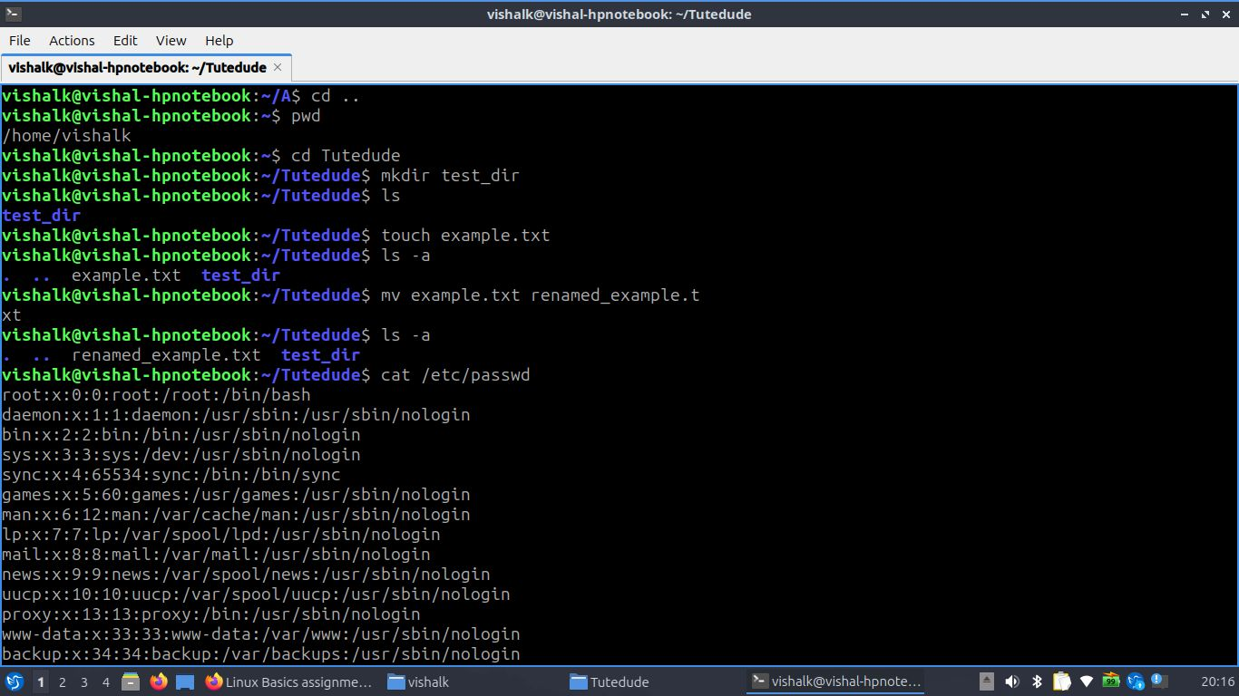
mkdir test_dir
cd test_dir
touch example.txt
mv example.txt renamed_example.txt

Explanation:
- mkdir test_dir is used to makes a new folder named test_dir
- cd test_dir is used to moves into that folder
- touch example.txt is used to creates an empty file called example.txt
- mv example.txt renamed_example.txt is used to renames the file

2. Viewing File Contents
Use cat to display the contents of /etc/passwd.
Display only the first 5 lines of /etc/passwd using head.
Display only the last 5 lines of /etc/passwd using tail.

Commands:
cat /etc/passwd
head -n 5 /etc/passwd
tail -n 5 /etc/passwd
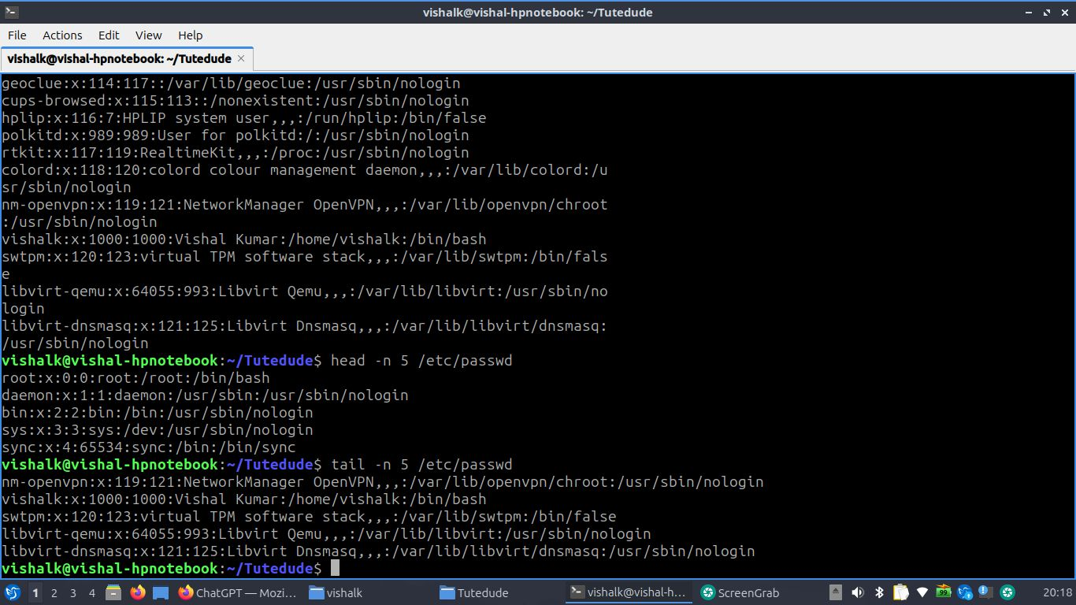

Explanation:
- cat /etc/passwd is used to shows the whole content of the file
- head -n 5 /etc/passwd is used to shows the first 5 lines
- tail -n 5 /etc/passwd is used to shows the last 5 lines

3.Searching for Patterns
Use grep to find all lines containing the word "root" in /etc/passwd.
Command:
grep "root" /etc/passwd
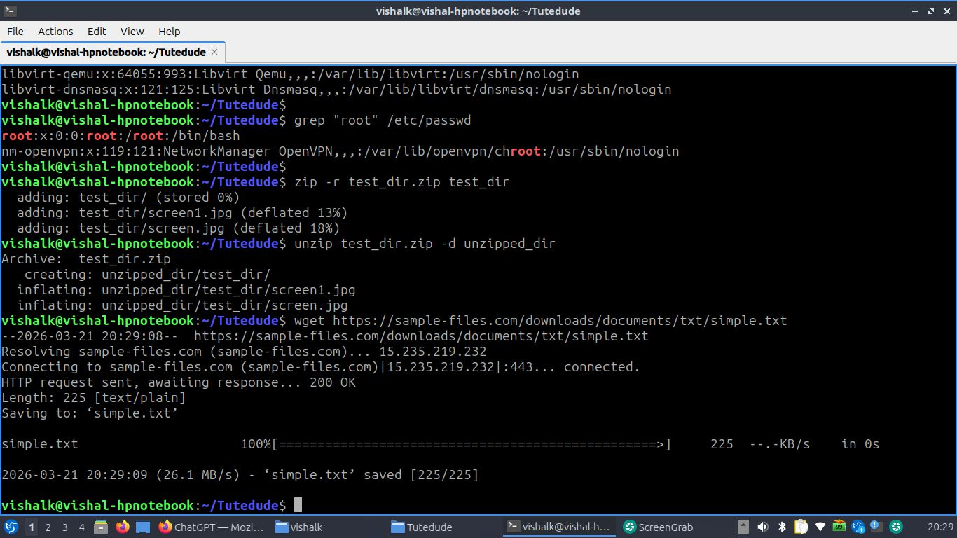
Explanation:
- grep "root" /etc/passwd is used to finds and prints all lines containing the word root

4. Zipping and Unzipping
Compress the test_dir directory into a file named test_dir.zip using zip.
Unzip test_dir.zip into a new directory named unzipped_dir.
Commands:
zip -r test_dir.zip test_dir
unzip test_dir.zip -d unzipped_dir
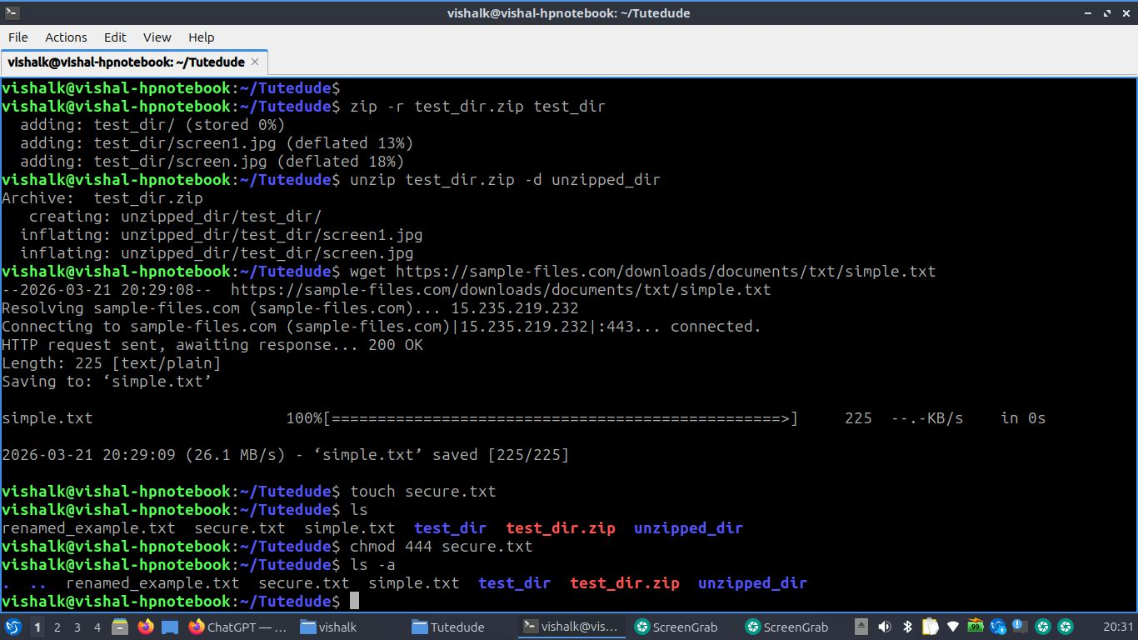
Explanation:
- zip -r test_dir.zip test_dir is used to compresses the folder test_dir into test_dir.zip
- unzip test_dir.zip -d unzipped_dir is used to extracts the zip file into a folder named unzipped_dir

5. Downloading Files
Use wget to download a file from a URL (e.g., https://example.com/sample.txt).
Commands:
wget https://sample-files.com/downloads/documents/txt/simple.txt
vishalk@vishal-hpnotebook:~/Tutedude$ wget https://sample-files.com/downloads/documents/txt/simple.txt
--2026-03-21 20:29:08-- https://sample-files.com/downloads/documents/txt/simple.txt
Resolving sample-files.com (sample-files.com)... 15.235.219.232
Connecting to sample-files.com (sample-files.com)|15.235.219.232|:443... connected.
HTTP request sent, awaiting response... 200 OK
Length: 225 [text/plain]
Saving to: ‘simple.txt’

simple.txt 100%[=================================================>] 225 --.-KB/s in 0s

2026-03-21 20:29:09 (26.1 MB/s) - ‘simple.txt’ saved [225/225]
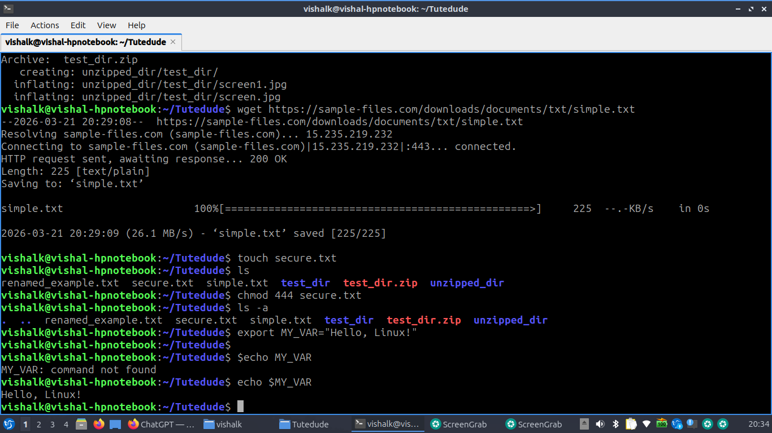

Explanation:
wget downloads files from the internet using the link provided

6. Changing Permissions
Create a file named secure.txt and change its permissions to read-only for everyone using chmod.
Commands:
touch secure.txt
chmod 444 secure.txt
vishalk@vishal-hpnotebook:~/Tutedude$ touch secure.txt
vishalk@vishal-hpnotebook:~/Tutedude$ ls
renamed_example.txt secure.txt simple.txt test_dir test_dir.zip unzipped_dir
vishalk@vishal-hpnotebook:~/Tutedude$ chmod 444 secure.txt

Explanation:
- touch secure.txt → creates the file
- chmod 444 secure.txt → changes permissions so everyone can only read the file (no writing or executing)

7. Working with Environment Variables
Use export to set a new environment variable called MY_VAR with the value "Hello, Linux!".

Command:
export MY_VAR="Hello, Linux!"

Explanation:
- export MY_VAR="Hello, Linux!" is used to creates a new environment variable named MY_VAR with the value Hello, Linux!
Github link: https://legendary-train-x5p54q6gq55q3p494.github.dev/

